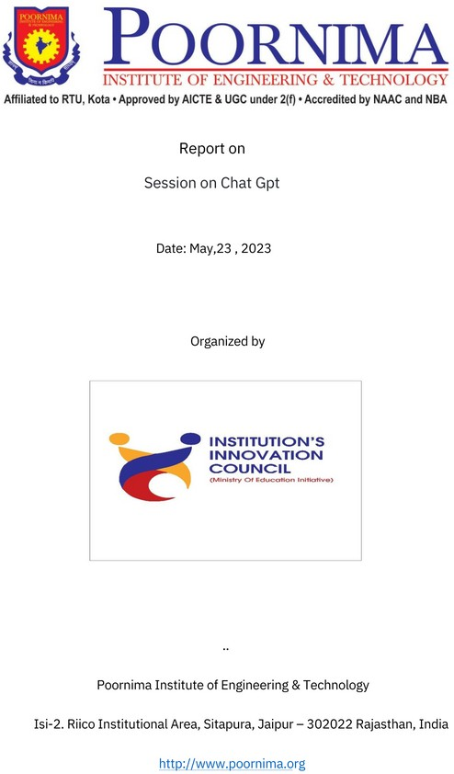

**Report: A Session on ChatGPT**

Date of Event: 17th May, 2023 Name of Event: ChatGPT Vertical Name: Yuva vertical Description:

ChatGPT is one of the most chosen and loved AI tools of the current time. ChatGPT is a sibling model to **InstructGPT**, which is Brief trained to follow an instruction in a prompt and provide a detailed response. In order to educate and aware the students about the ChatGPT & its optimal usage, the Yi Club (PIET) organised a session to cover basics of ChatGPT on 17 May 2023.

The workshop started with a formal introduction and felicitation of the guests & speakers, Mr Gaurav Bansal (Co-chair, Yi Jaipur) , Mrs. Ayushi Agarwal (Co-chair, Yuva vertical, Yi Jaipur), and Mr Deepak Sihag (Founder xLab IT consultancy services) by Dr. Dinesh Goyal Sir, Principal, PIET. Then Deepak sir led the session and taught the students about the AI tool , initialising with the basics and coming to the practical part.

The session continued for about two hours and concluded on a positive note as the students were quite enthusiastic about it. All the guests were presented a memento as a token of honour and respect by Dr. Gautam Singh sir, Registrar PIET.

The session was organised & volunteered by Parv Sharma, President (II year), Sejal Rai, Secretary (II year), Gargi Sharma, Rhythm Verma, and Vikas Sharma (II year).

Number of Members Engaged: 85 Number of Thalir Engaged: 0 Number of YUVA Engaged: 79

Number of Rural Initiatives Engaged : 0

Direct Impact: 79 Impact Story:

AI is what many researchers believe will shape our tomorrow and so will all the

AI tools. ChatGPT is one of the most famous and widely used tools of today’s time. However, most of us aren’t even able to use 10% of its potential and are completely unknown.

Through this session on ChatGPT, the engaged students were able to identify how to command this AI tool properly. They got to know that these commands are called prompts and in order to pull ChatGPT’s strings, one must be able to diﬀerentiate it in three parts.

The attendees were inculcated with various methods of prompting ChatGPT, or what we call instructing it to perform various tasks. They were even able to write the lyrics of a song and generate a full rap-song from ChatGPT. They also learned how to combine other tools with ChatGPT to complete the music of that rap-song, lyrics of which they created earlier.

With this knowledge, they’ll also be able to generate code templates, modify & debug them with ease. Through this session, students will be able to achieve desirable results from ChatGPT, or any other AI tool, that may come in future. Also, they got to know about future prompt engineering scope for their career paths.

